Kol Simcha Torah Gazette
For Pesach/Parshas shemini 5786
Vol 10 Issue 26 (Whole #491) 17 Nissan 5786/ April 2-4, 2026
Printed L’illuy nishmas Nechama bas R’ Noach, a”h
For a free subscription, please forward your request to keren18@juno.com
Past emails can be found on the website ShabbosStories.com under Brooklyn Torah Gazette

The Three Main Passover Symbols: Pesach,
Matzah and Maror
By Debbie Gutfreund

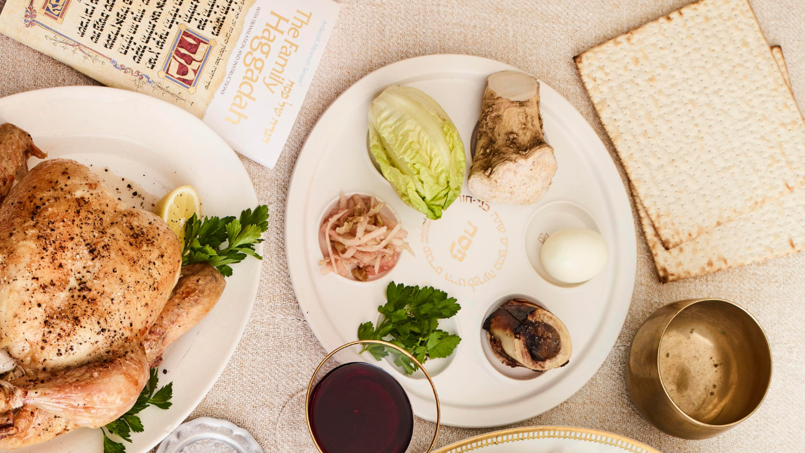
The powerful gifts of gratitude, hope and grit.
What’s the most important part of the Passover Seder? I’ll receive many different answers. My great grandfather would have said singing the Hagaddah in the tune that his own grandfather sang the words. My Uncle Leo would have said the delicious food. All the children would have said running around the house trying to find the Afikomen. And my grandmother would have said having the whole family together around the table.
But there is actually one part of the Seder that is the most important for all of us, and we are all obligated to recite it when it comes up in the Haggadah and understand it.
“Rabban Gamliel used to say: Whoever has not explained the following three things on Pesach has not fulfilled his duty: Pesach, Matzah and Maror.”

The Meaning of Passover Symbols
Pesach - The Shank Bone
The shank bone symbolizes the sacrifice that the Jews in Egypt gave to thank G-d for the miracle of passing over their houses during the tenth plague in which all the Egyptian’s firstborn died. What can we learn from this sacrifice of gratitude? Just as the Jews thanked G-d for passing over their houses in Egypt and protecting them from the fate of the Egyptians, we can learn to thank G-d for the everyday miracles when we are spared from harm in the first place. Driving somewhere and arriving safely. Not getting sick. Not being hungry.
This Passover, think about all the hidden and open miracles that G-d has done for you in the past year and thank Him for the incalculable number of “ordinary” moments in which He saved you from harm without you even realizing it.

Matzah - The Unleavened Bread
Matzah is the unleavened bread that the Israelites brought with them when they left Egypt. Matzah teaches that G-d doesn’t need any time to prepare; He can save us in an instant. Since He can turn everything around in a moment, we should never give up hope. And when things are going well, we should remind ourselves that this too is an ongoing miracle. G-d is with us in this moment even when it seems like everything is just proceeding as “it should.”
When we look at the matzah, think about the times in your life when everything turned around in a moment, seemingly without any warning or effort on your part and how G-d can do the same for you today, no matter what your challenges may be.

Maror - The Bitter Herb
Maror is the bitter herb that reminds us of the tears that the Jewish people cried when they were slaves in Egypt. It teaches that when we are going through challenging, seemingly bitter times, sweetness and light and hope are just around the corner. Maror reminds us not to avoid obstacles but to instead recognize that they are a necessary part of the process of success. Without our tears and our prayers, the Jewish nation would not have been able to leave Egypt. Without the bitterness and the struggle, we don’t reach our full potential.
When you look at the maror, think of a struggle you have gone through in the past year and how it helped you become who you are today.
Pesach, matzah, maror symbolize gratitude, hope and grit. With these three powerful gifts we sit around our Seder tables and thank G-d for the miracle of our freedom.
(The Pesach and matzah explanations are based on Rav Moshe Feinstein ztz”l explanations found in The Reb Moshe Haggada)

Reprinted from the current website of aish.com
At My First Seder, I Wondered Why
There Was No Bread
By Sofya Sara Esther Tamarkin

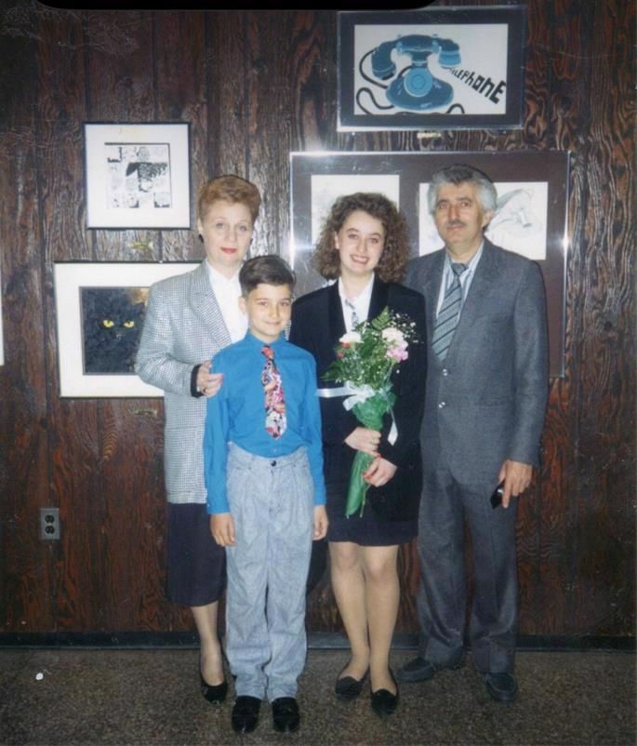
The family shortly after arriving in the United States.

I was a young teen in 1990, newly arrived in the US from Russia, and found myself at my first ever Passover Seder with no idea what was going on.
My grandmother Zelda had been shopping for chicken at the local Philadelphia supermarket. She wanted to ask for a lower price, but did not speak English, so she tried Yiddish, the only language she knew besides Russian.
Imagine her surprise when her request was understood not by the cashier, but by a woman behind her in line! The woman introduced herself as Mrs. Batsheva Shemtov, who, together with her husband, Avraham, had been sent to Philadelphia by the Rebbe.
Recognizing that the poultry my grandmother had chosen was not kosher, Mrs. Shemtov showed her that the store also sold kosher chicken. My grandmother was bewildered; she had not heard about kosher in decades.
I don’t know what my grandmother decided to do about the chicken, but their encounter changed the course of my entire life.
Mrs. Shemtov understood that we had recently arrived from the Soviet Union and invited us all to the upcoming holiday of Passover. This would be our first encounter with Jewish tradition in America. I remember looking forward to having dinner with “real” American Jews.
As immigrants, we couldn't afford lavish meals, and I was excited for an opportunity to enjoy great food. At the time, we had absolutely no idea that this would be anything other than a fancy dinner.
I remember being seated amongst other guests at a long table. The Shemtovs were full of excitement because they understood that it was our first Passover celebration.
The table was set with rather strange items: grated apples, a bone, celery, and eggs. I was surprised not to find bread and butter on the table because for me, that was a staple of any meal. We came in anticipation of a feast, and when I saw that the menu consisted of salt water and vegetables, I felt genuinely confused.
I carefully observed Rabbi Shemtov, who was following instructions written in a small book. The Seder was conducted in English and Hebrew, neither of which I understood. We followed his lead, and everyone drank wine from gorgeous crystal goblets. We were then instructed to eat items set in front of us in a particular order.
I couldn't understand what the rabbi was saying, but I instinctively understood that there was meaning behind these traditions. Mrs. Shemtov saw our confusion and smiled at us kindly. She came over and spoke with my grandmother in Yiddish, and my grandmother tried to translate for us whatever Mrs. Shemtov explained about the holiday.
When I look back at that first Seder, two lessons stand out to me.
First, just because I don’t see the full picture doesn’t mean there isn’t an important explanation. That evening, I didn’t understand the meaning behind the items set out on the table, but that didn’t mean there was no order to it. Often, now, when I encounter situations that seem confusing or chaotic, I think of my first Seder. Ironically, that evening was all about order (seder is Hebrew for “order”) and my inability to understand it didn’t change or diminish the wisdom behind every ritual of the night.

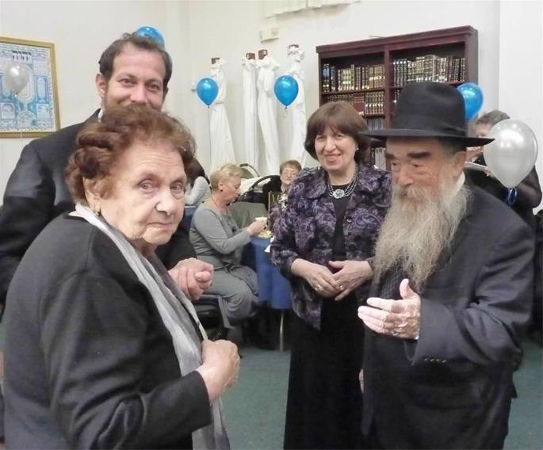
Grandma Zelda and the Shemtovs at her grandson's bar mitzvah.

And second, I realized that change takes time, patience, perseverance, and courage. If I had known at the outset how much work would be required from me to familiarize myself with my Jewish heritage, I would have been far too overwhelmed to embark on the journey. It took decades of consistent learning and investing in experiences to embrace my Jewish identity.
Each year, as I set my table with the Seder plate, I smile to myself and think about my first Passover. And while I rejoice in understanding the order of the night, I hope not to lose touch with my 13-year-old self, who was curious enough to bring me to this moment. (And my third lesson, perhaps, is to never stop asking questions. After all, isn't that what this night is all about?)

Reprinted the Chabad.Org website for Pesach
Body and Soul – a Powerful
Insight from Parshat Shemini
Compiled by Mordechai Rubin
From the Teachings of the Lubavitcher Rebbe
Rabbi Menachem Mendel Schneerson, Zt”l
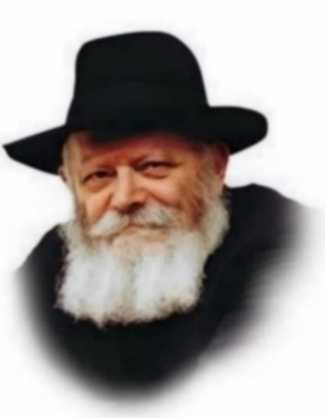

In the 11th chapter of Leviticus, the Torah discusses some of the laws of ritual impurity, food that comes in contact with a source of impurity is rendered ritually impure.
The above-quoted verse touches on two of the necessary conditions before a foodstuff is susceptible to contamination: 1) The food in question must be fit for human consumption. 2) It must first come in contact with water or one of the other "seven liquids".
Man is a synthesis of body and soul, the Torah that instructs and inspires one’s life likewise possesses both a "physical" element as well as a conceptual-spiritual side. The "body" of Torah is its legal code and pragmatic guide to daily living; its "soul" is the inner dimension of these laws, which addresses the internal world of the human mind and heart, man's relationship with his Creator and his purpose in life.
The is also true of the laws regarding the ritual impurity of food. These, too, have a moral-spiritual application to our lives.
The first law recounted above—that only food that is fit for human consumption is open to contamination—expresses the idea that the loftier a thing, the more vulnerable is it to corruption. Animal fodder is of a limited potential; equally limited are its negative uses. But the food that drives the human mind and heart can be the instrument of tremendous achievement; conversely, it may fuel the most destructive endeavors.

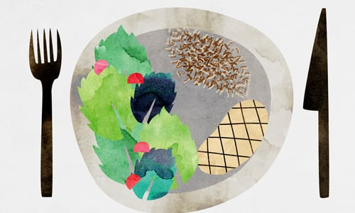
Art by Sefira Lightstone

The same applies to all areas of life. A person may choose to "play it safe" and avoid anything touched by controversy, risk, or the possibility of failure---anything that may challenge his spiritual purity. But in doing so, he also disavows his most lofty potentials, the vulnerable but invaluable "human food" resources of his life.

Reprinted from the Chabad.Org website.

Rav Avigdor Miller on
The Gift of Eretz Yisroel

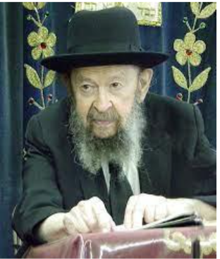

QUESTION: Why do we thank Hashem in birkas hamazon for Eretz Yisroel, especially when in fact, we were exiled? Why not thank Him for all the world instead of just Israel?
ANSWER: Why in the birkas hamazon, when we thank for our food, do we thank Hashem for Eretz Yisroel, instead of thanking Him for the world in general?
Now actually we do thank Him for the world in general. The first bracha is הזן את העולם כולו – He who feeds the entire world, which means that grain grows in Russia and rice grows in China and things grow all over the world and we thank Hashem. Where do they grow from? They don’t grow from the air they grow from the soil. And therefore, we thank Him for the world. He’s the King of the world and He gave us food.
But we thank Him for Eretz Yisroel for a different reason. The fact that we’re in exile doesn’t change anything. Eretz Yisroel is a gift that’s given to us forever. The fact that we’re not there right now or that there are people who want to deprive us of our rights, makes no difference. It’s ours. It’s such a great gift that we should never stop thanking Him for that, and we’re going to retrieve it.
Sooner or later, we’re going to kick everybody out of Eretz Yisroel. We won’t do it ourselves. We’ll do it with the Melech HaMoshiach, but everybody will have to leave. Moshiach will come and say, “I’m sorry gentlemen, this is occupied. It’s reserved. Get out of here. And if you won’t get out, we’ll have to take action like we did in the days when Yehoshua entered the land.” And so, we thank Hashem, it’s our land forever.
Suppose somebody gave you $100,000 dollars in the safe department box, but right now you can’t find the key. You come to the bank and you want admission to the vault because you have $100,000. They say, “Where’s your key?” You don’t have it. “Sorry boy, I can’t give it to you.” So, you’re not going to thank that man? Someday you’ll get the key back again. As long as you have it, you’re happy and you’re thanking Him forever and ever.

Reprinted from the Parshas Vayikra 5786 edition of Toras Avigdor. (Transcribed from a classic Thursday night hashkafah lecture delivered by Rav Avigdor Miller in December 1982.)

Reflections on the Song – “Dayeinu”

Perhaps one of the most perplexing parts of the Haggadah is the song known as “Dayenu,” in which we say that if G-d had taken us out of Egypt but not judged the Egyptians, that would have been enough for us. Or, if He had judged the Egyptians, but not destroyed their idols, that, too, would have been enough for us.
Or, if He had destroyed their idols, but not killed their firstborns, that, too, would have been enough.
Or…What does this song mean? Rav Eliyahu Hakohen Ha’itamari z”l (Izmir, Turkey; died 1729) explains: For each of the Divine gifts or miracles listed in this song, one could argue that G-d should have acted otherwise.
We praise G-d that He considered all these arguments and acted in the way that was best for us and for the glory of His Name. For example, one could argue that if He had taken us out of Egypt but not judged the Egyptians so harshly as to practically destroy them, His name would have been magnified even more, for the
Egyptians would live to remember, and to tell others, how He had humbled them.
On the other hand, one could argue that they would not feel humbled in that event. Rather, they would say, “He won this battle, and we will win the next battle.” That is why G-d judged the Egyptians harshly. Still, one could argue that if He had judged the Egyptians harshly but not destroyed their idols, those idols would have served as constant reminders of G-d’s power to anyone who saw them. On the other hand, some people would say that G-d wasn’t strong enough to destroy the Egyptians’ idols. That is why G-d destroyed the Egyptians’ idols.

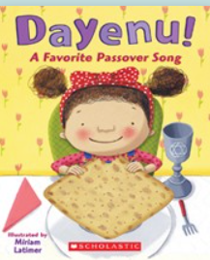

But, one could argue that if He had destroyed their idols, but not killed their firstborns, then those firstborns would have had a special reason to tell others of G-d’s greatness. It was customary at that time to devote one’s firstborn to the service of the idol; with all the idols destroyed, the Egyptian firstborn, who were no longer performing that service, would be a testament to G-d’s power.
On the other hand, Pharaoh was a firstborn; if the firstborns had not been smitten, people would say that it was Pharaoh’s merit or power which saved him and those like him. That’s why G-d killed the firstborn . . . (Minchat Eliyahu ch.32)

Reprinted from the Pesach 5786 email of R’ Yedidye Hirtenfeld’s whY I Matter parsha sheet for the Young Israel of Midwood in Brooklyn, NY 11230.

